So far what we did is we have dumped the .war file from maven build tool in the Tomcat server we have not Tested the .war file or the source code using sonarqube tool before dumping the source code(.war file) In to the Tomcat server.

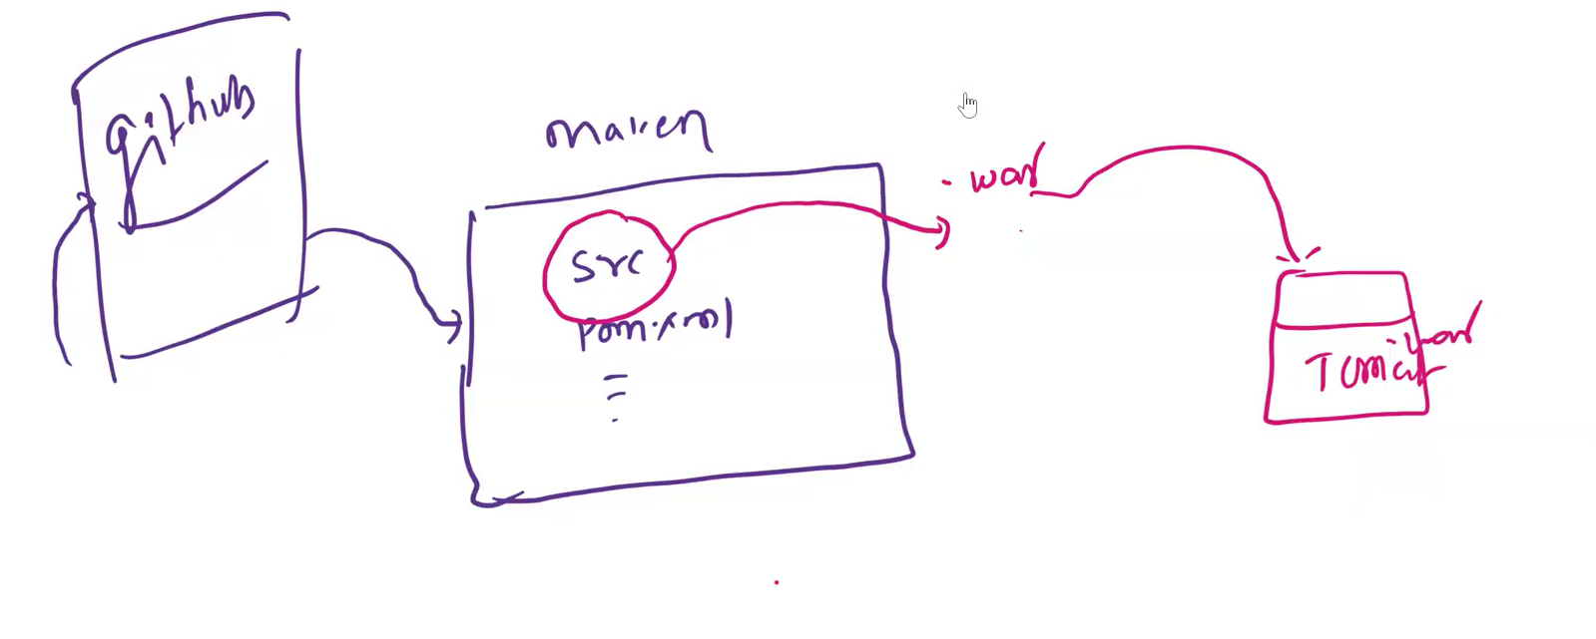

Before deploying the source code(.war file) in to the Tomcat server we have to test it using sonaqube server and once upload the source code in to the sonarqube server it will generate the test report and display the report to the development team
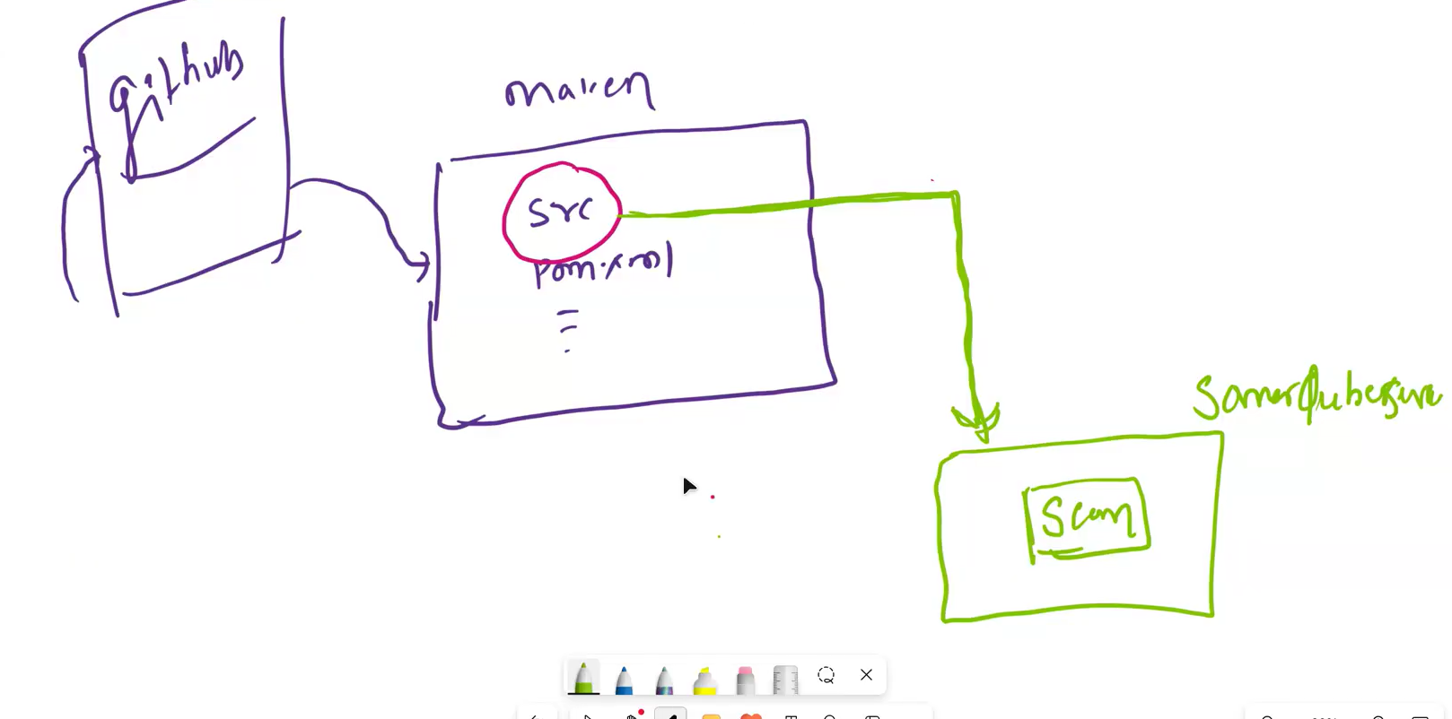
In this class, our agenda is to establish a connection between the Maven build tool and the SonarQube server.
To create this connection, we need to provide the SonarQube credentials (username and password). Although the recommended practice is to configure these credentials securely using the settings.xml file or environment variables, in our case, the trainer is adding the credentials directly into the pom.xml file for demonstration purposes.
Once the credentials are added to the pom.xml, we can use Maven to dump the source code into the SonarQube server, which will then generate the test and code quality report.
After adding the credentials to the pom.xml file, we execute the following Maven command to initiate the SonarQube analysis and build the project:
mvn sonar:sonar package
Running this command will trigger the SonarQube scan and send the code analysis results to the SonarQube server. This process effectively establishes the connection between Maven and SonarQube, allowing us to view the test and code quality reports on the SonarQube dashboard.
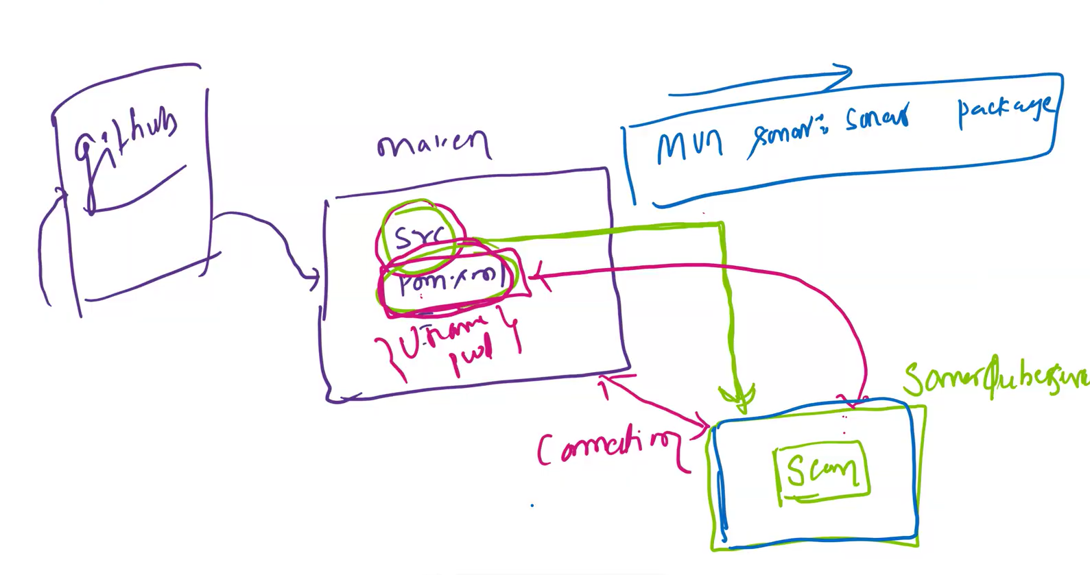
Let’s start the sonarqube server (/opt/sonarqube/bin/linux-x86-64 )
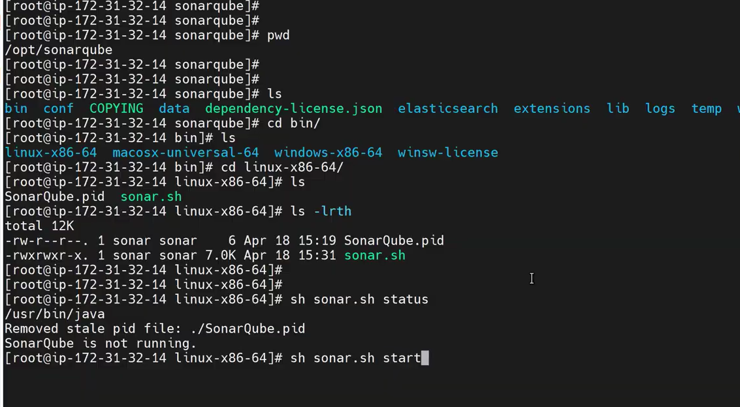
on the web run this ip address 3.110.88.1:9000
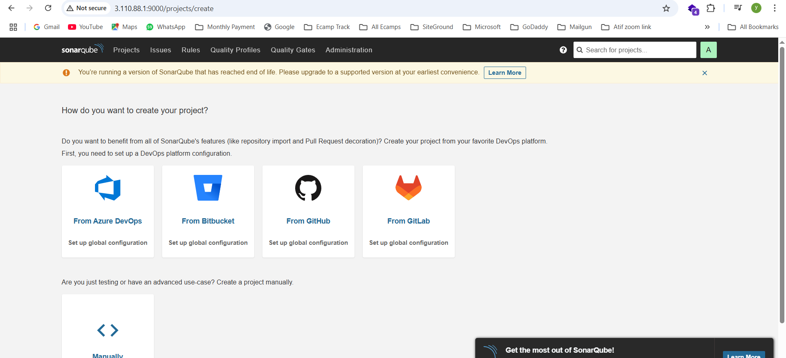
A very important thing to oberserve
In the image below, you can see that there is a common mistake: we are unable to start the SonarQube server. The reason is that we are trying to start the SonarQube service using the root user, instead of the dedicated sonar user that was created during setup.
Note: SonarQube is designed not to run as root for security reasons. It must be started using a non-root user like sonar
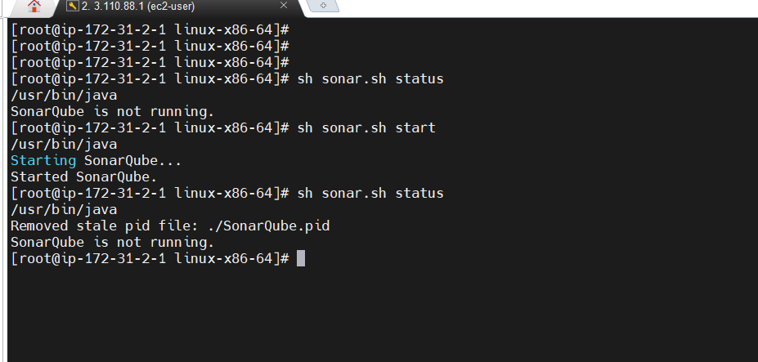
switch to sonar user first and then start the server
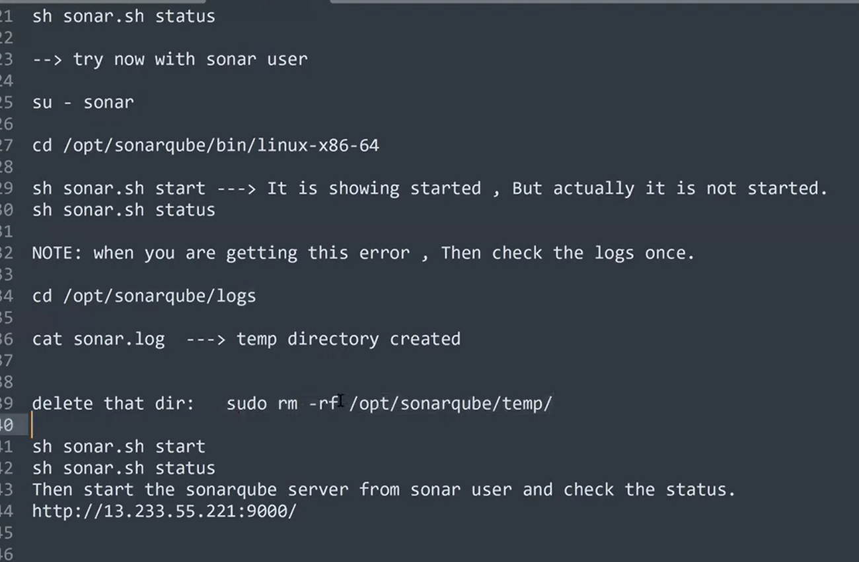
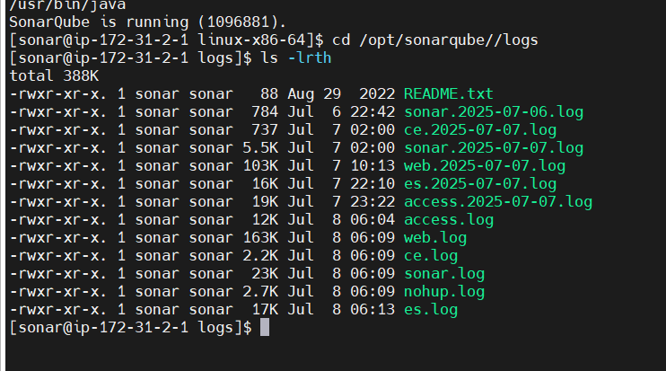
execute the command cat sonar.log
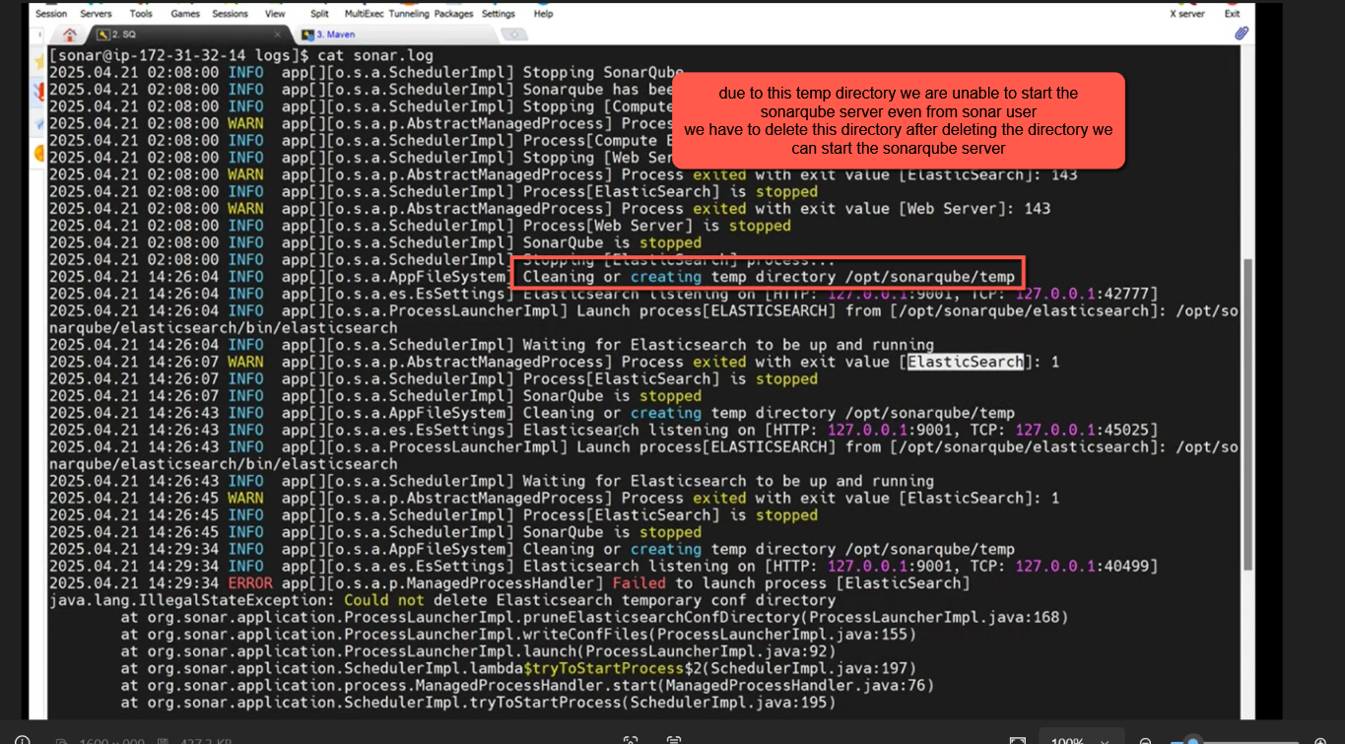
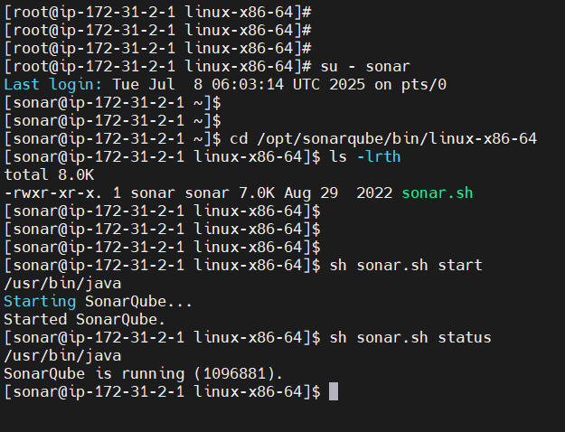
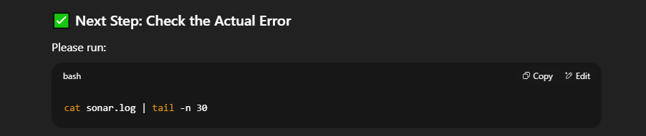
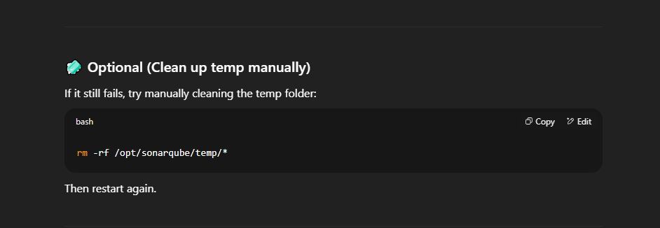
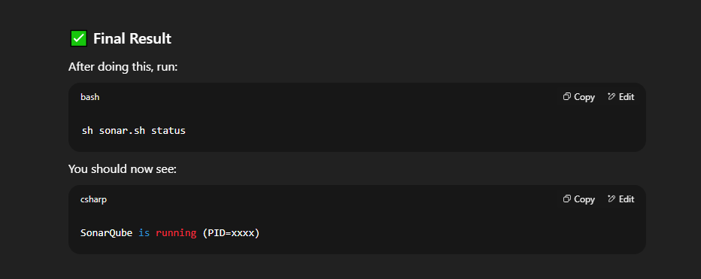
Now lets see How to generate a sonarqube report :
Before generating the sonarqube report we have to add the sonarqube server details in pom.xml file of the maven’s Java Project
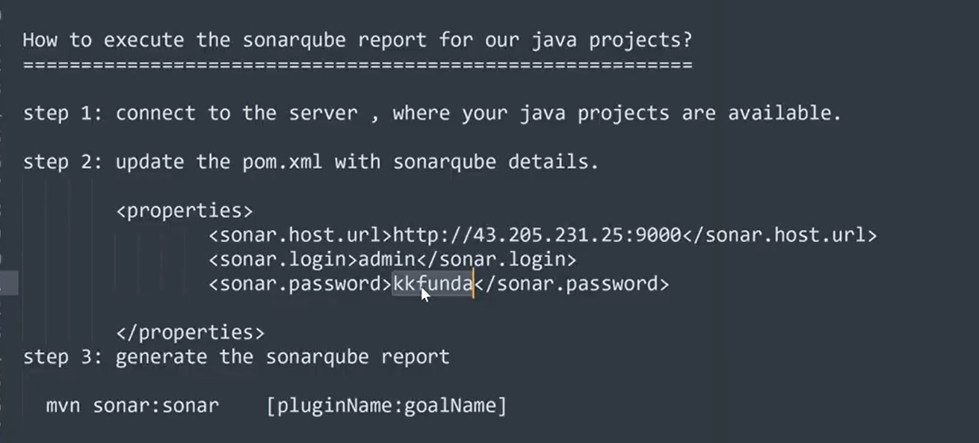
Add the sonarqube server url , login username , password in the properties tag of pom.xml file
Instead of adding these credentials details manually hardcode we can encrypt them with the help of Anisble vault
we can also generate and use Token instead
Let’s open the Maven Java project and add the sonarqube server details(ip,username,pass) in the pom.xml file
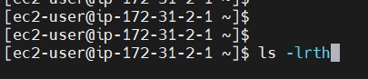
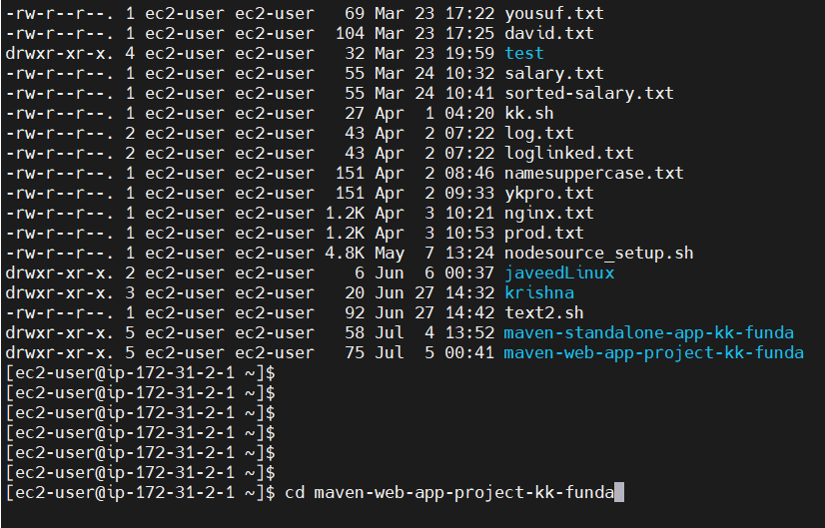
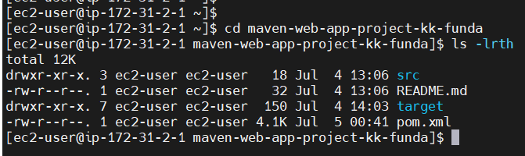
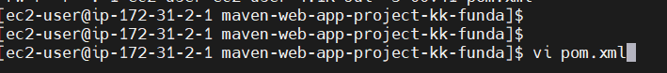
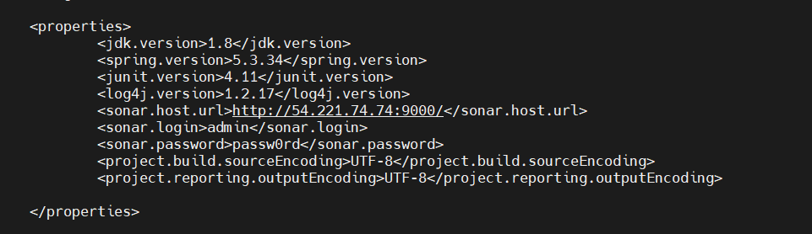
add our sonarqube server details after adding them run the sonarqube commands
right now in pom.xml has different sonarqube server details so when we execute sonarqube commands
the reports will not be generated because of having other sonarqube server details in the pom.xml file
Lets execute the sonarqube commands and see what would we be the result as our pom.xml different sonarqube server details
mvn clean sonar:sonar package
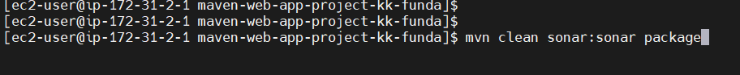
As you can see in the below image there is a build failure . lets ask chatgpt for the reason
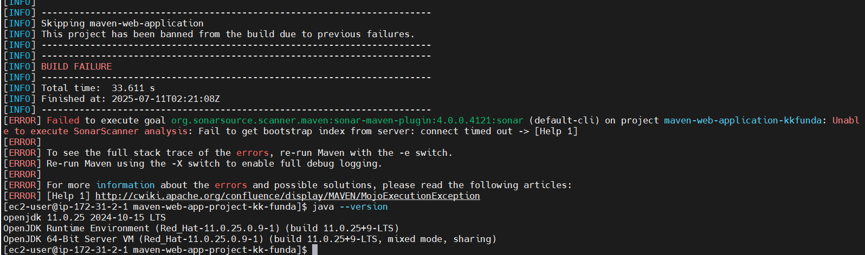
Answer from chatgpt below
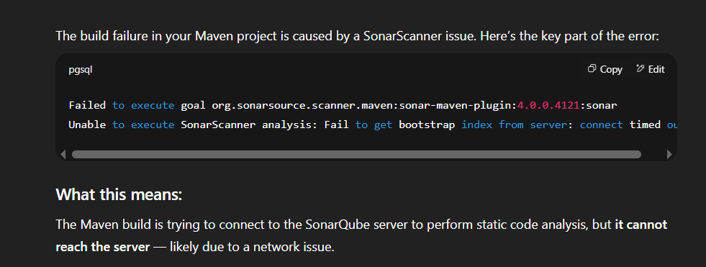
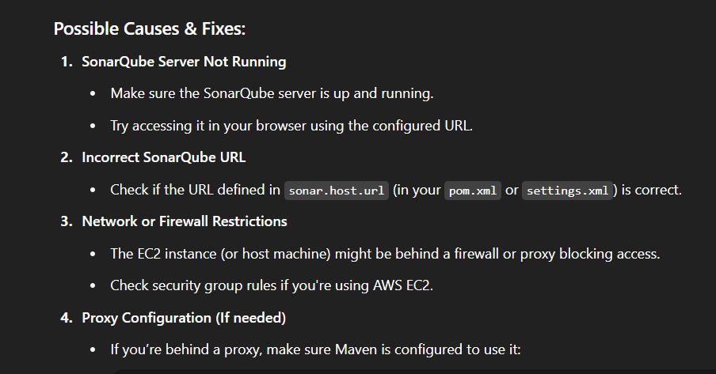
Now lets add our sonaqrqube server details in pom.xml file
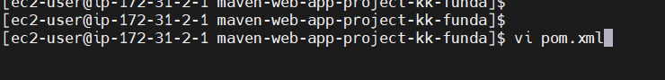
update or added the our sonarqube server credentials as shown in the below image
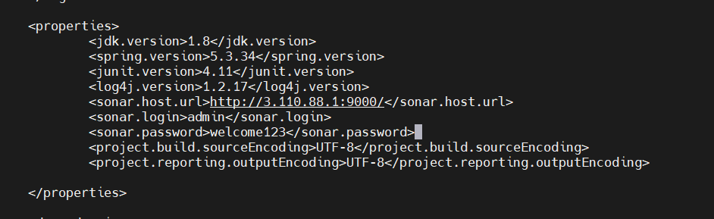
Now lets execute the below sonar command
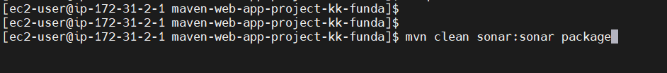
wow in the below image you can see we successfully connected our sonar server with java web application project
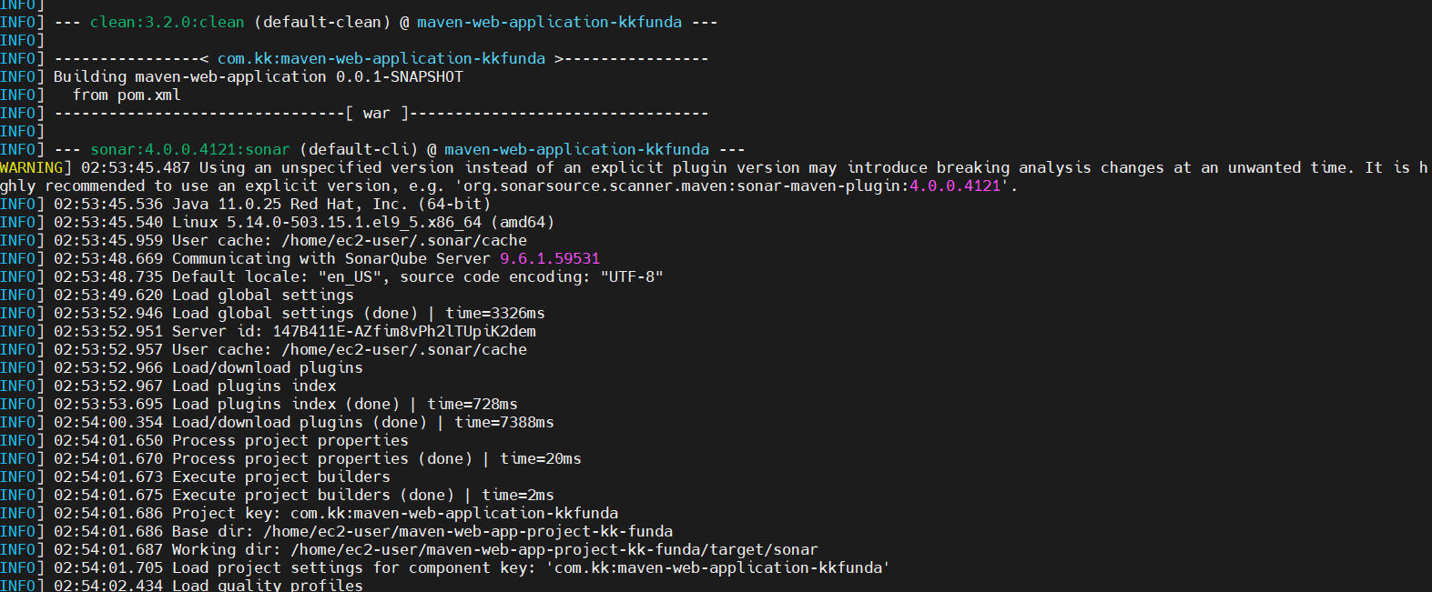
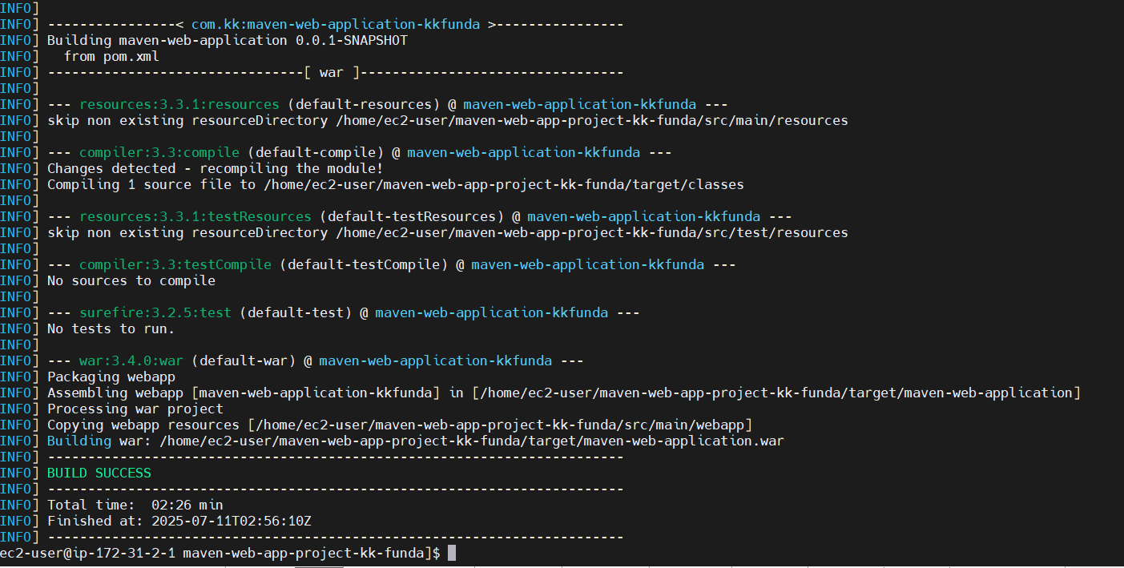
now in the sonarqubeserver ui you can find the Java maven web application sonarqube server report as shown in the below image
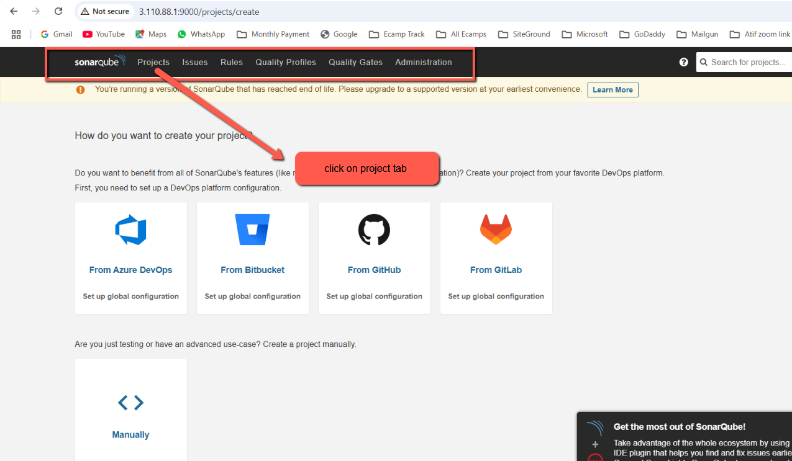
In the below image you can see the our java web application project sonar report has been generated. The test cases has been passedand we should not be worry about these reports it will be taken care by developer or testing engineer our work is only to integrate sonarqube server with maven java project
